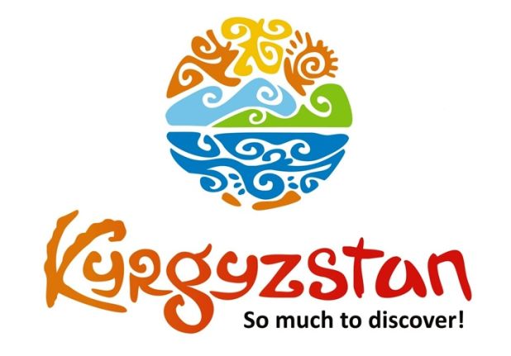**Horse games festival in Son-Kol 2018**

Country: **Kyrgyzstan**

Type: **experience nomad life**

Period: fixed dates **July 20, 2018 – July 28, 2018**

**Days: 9 / Nights: 8**

Organizing any complexity of tours to Issyk-Kul, Son-Kul, around Kyrgyzstan and Central Asia. We guarantee you high quality of service and individual approach!

This ‘fixed dates tour’ includes following “must visit” places and activities:

* Bishkek City - the biggest city and the capital of Kyrgyzstan
* Burana tower on the place of ancient city of Balasagyn
* Issykkul - the second largest mountain lake in the world - so-called “pearl of Kyrgyzstan”
* Karakol (and the leading farm in the breeding livestock on the way)
* Jyrgalan Valley - one of “culturest” places where you will “try” local nomadic life and enjoy your time!
* Son-Kol - on the way you will visit seven rocks and see falcon hunting.
* Chon-Kemin - dinner with a folklore performance and full day of Horseback riding to Kalmak Ashuu George

**Main national games will take place in Son-Kol**

During the tour you will:

* enjoy the breathtaking pure air, stunning views of mountains, lakes and rivers during the hall trip,
* experience nomadic lifestyle, interact with shepherds and their families, watch them run household duties like milking mares, making Kymyz, take part in preparing food, take care of livestock etc.,
* walk to nearby place where will be festival of traditional Kyrgyz horse games such as Ulak-Tartysh, KyzKuumai, Tyiynenmei, Erenish which will follow with folklore show and Kyrgyz cuisine.

**Day 1: 20.07 - Arrival to Bishkek**

After checking in the hotel you will have a half-day sightseeing tour of Bishkek city including all main historical and amusement places. It will finish by excursion to colorful market Osh Bazar to feel the real sense of Central Asian life by watching merchants selling their products, people of all ages and different ethnic groups, nationalities who live in Kyrgyzstan.

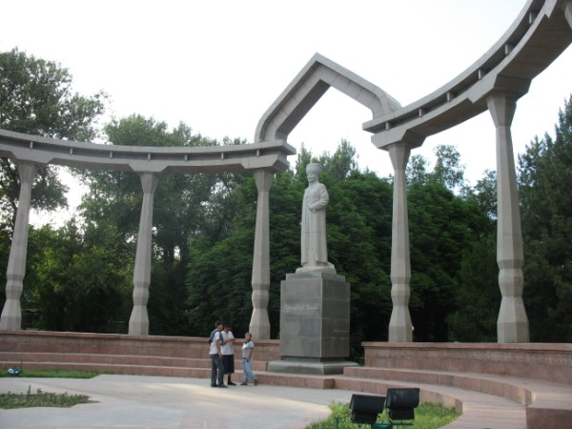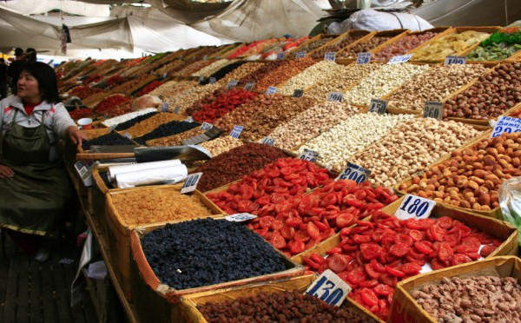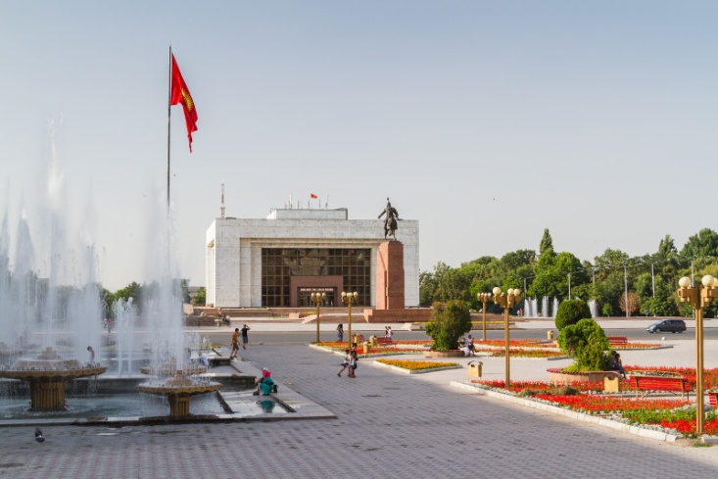

**Day 2: 21.07 - Bishkek - Cholpon-Ata**

Departure to Issyk-Kul with en-route stop in Tokmak to visit remains of ancient city Balasagyn with a minaret, an open air museum of Balbals and a small archeological museum.

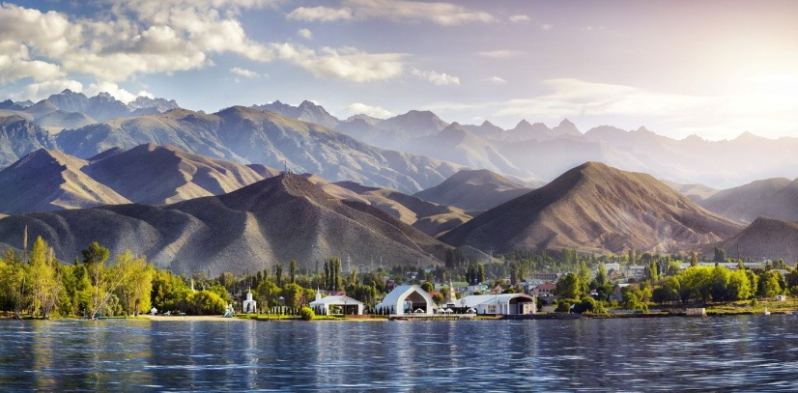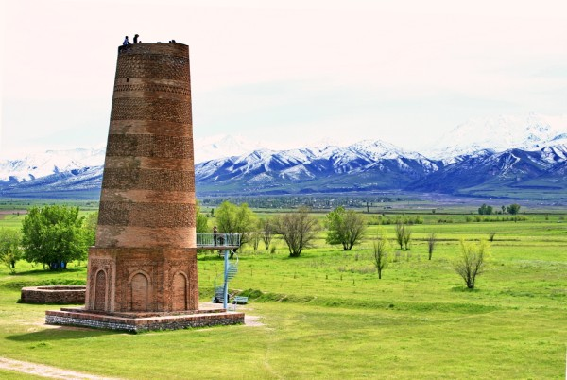

Upon arrival to Cholpon-Ata visit open air Museum of Petroglyph’s (stone inscriptions)

Rukh-Ordo cultural complex and Regional Museum. Lunch in a local cafe.

Boat tour is possible to arrange.

After checking-in to hotel you will have evening free time and Dinner at the hotel.

**Day 3: 22.07 - Cholpon-Ata – Karakol**

A scenic road to far eastern part of Issyk-Kul Lake to Karakol town. We will have a stop on the way to visit eco-farm Reina-Kench at Tepke village. You will have a guided tour around the farm followed with organic lunch in the open air along the Jyrgalan River.

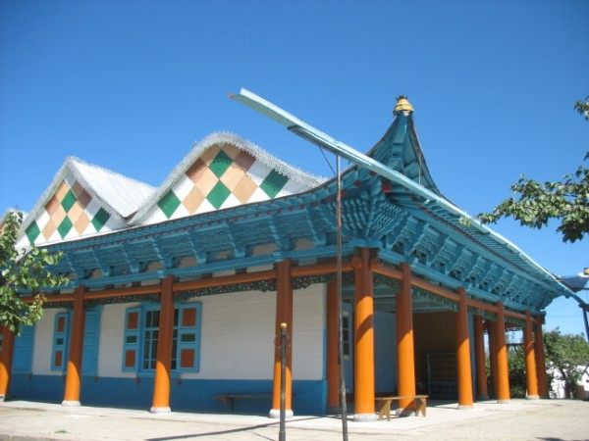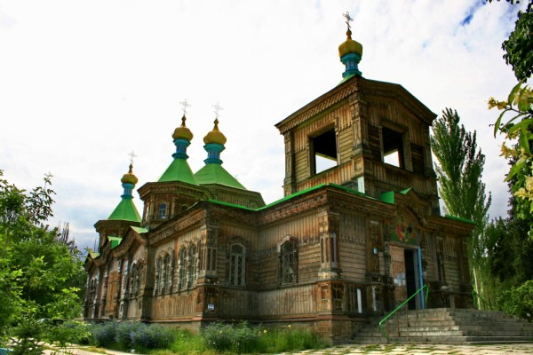

We will also visit Przewalski Museum – a Soviet renowned explorer of Central and Eastern Asia. Then we have a visit to the old wooden Dungan Mosque built without nails, old wooden Russian Church and One Village-One Product local shop.

**Day 4: 23.07 - Karakol - Jyrgalan valley**

Today you will visit one of the beautiful valleys - Jyrgalan. Enjoy the gorgeous drive to the valley along the scenic road that passes through small villages surrounded by sharply inclined peaks.

You will enjoy the breathtaking pure air, Crystal River Jyrgalan that flows from the peaks and several old Soviet buildings still standing there today. You will be met by locals who will greet you and by having an excursion around the village.

After lunch you will go for half-day hiking tour to Turnaluu-Kol Lake and enjoy the stunning view.

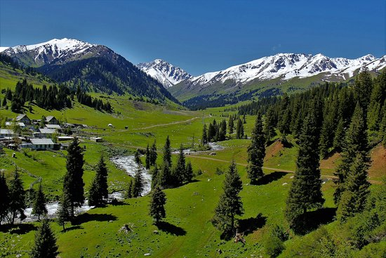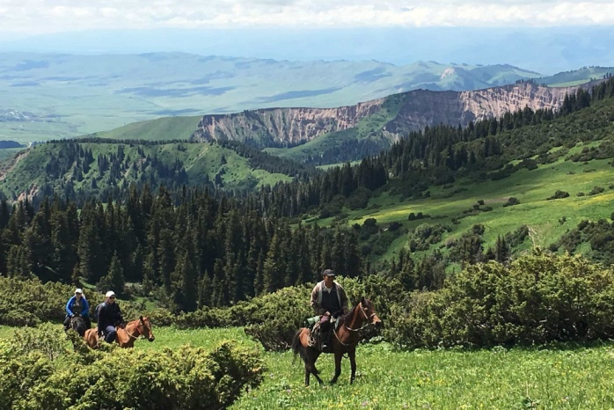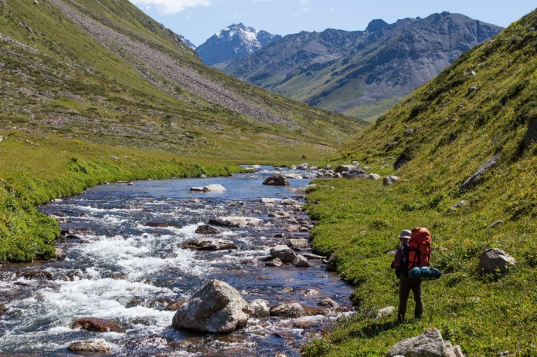

**Day 5: 24.07 - Jyrgalan valley - Lake Son-Kol**

This day will start early. When passing by you will visit a popular tourist destination with red colored gorges at Jeti-Ogyz (Seven Bulls) Gorge.

After arrival to Bokonbaev village (south shore) we will visit a local Kyrgyz Burkutchu’s (hunter) house who keeps falcons at his house (small falcon farm).

Lunch at a local Kyrgyz family’s house. Then continue driving to beautiful alpine lake Son-Kol (3016m).

The road to the lake has stunning views of Tien-Shan Mountains, green pastures where you can see herding horses and sheep, small mountains rivers and definitely local nomads with their yurts. You can stop and visit nomads where you will be offered bread and national drink Kymyz (fermented mare’s milk) as a mean of their hospitality.

Accommodation at yurt camp.



**Day 6: 25.07 - Son-Kol**

Full-day for observing and experiencing nomadic lifestyle, interacting with shepherds and their families, watch them run household duties like milking mares, making Kymyz, taking part in preparing food, taking care of livestock etc. You will walk to nearby place where will be festival of traditional Kyrgyz horse games such as Ulak-Tartysh, KyzKuumai, Tyiynenmei, Erenish which will follow with folklore show and Kyrgyz cuisine.

Dinner and accommodation in a camp.



**Day 7: 26.07 - Lake Son-Kol - Chon-Kemin**

After breakfast departure to Chon Kemin valley. On the way we will stop at Kochkor village to visit Altyn-Kol (Golden Hands) local shop for famous Kyrgyz felt carpets and other felt products. You will observe as well as participate in making felt carpet with locals and lunch in a local family.

Arrival to guest house in Chong Kemin, dinner in the yard of the guest house followed with bonfire and Akyn singing folk songs on komuz and accordion.

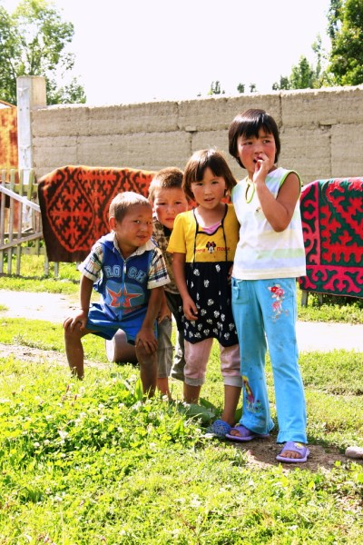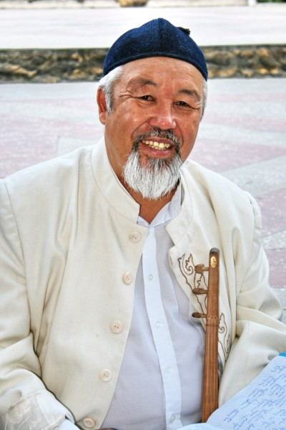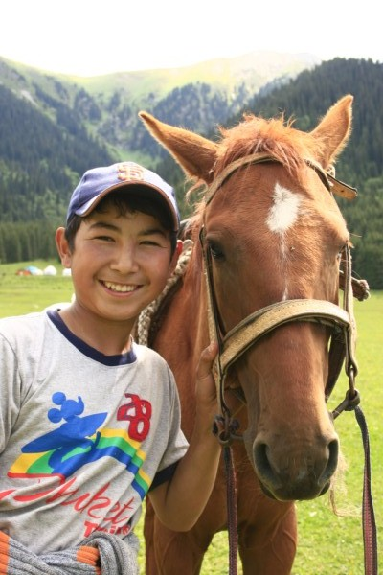

**Day 8: 27.07 - Chon-Kemin – Bishkek**

After breakfast we will have a Half-day excursion tour to KalmakAshuu Gorge (on horses and/or horse carts).

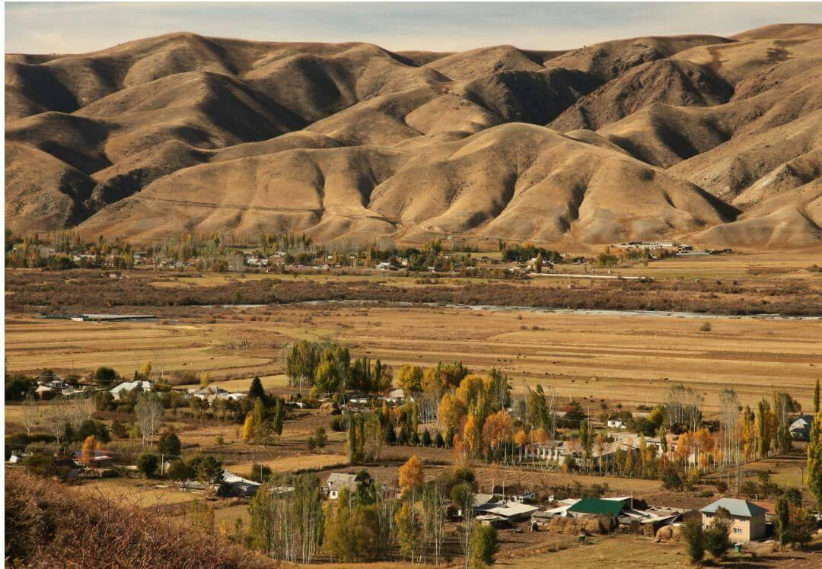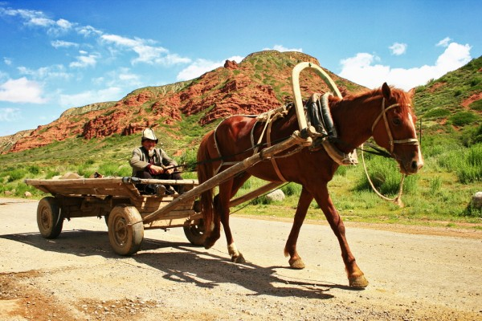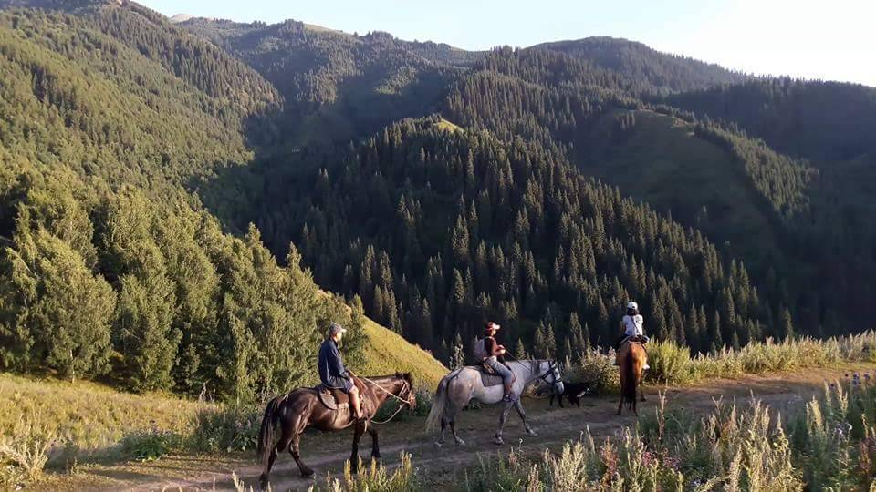

After arrival back to guest house we will depart to Bishkek. This evening will be free.

**Day 9: 28.07 - Departure from Bishkek**

After breakfast you will be transferred to the airport for your departure flight.

| **GROUP SIZE** | **PRICE IN USD/PER PERSON** |
| --- | --- |
| 5 | 1150 USD |
| Supplementary for single accommodation | 198 USD |

**The price is guaranteed with minimum 5 people in the group**  
For individual departures, please, contact us at [info@travelscruiser.com](mailto:info@travelscruiser.com)

| **TOUR PRICE INCLUDES** |  |
| --- | --- |
| Accommodation - twin based | Bishkek - 3* hotel (2 o/n)  Issyk-Kul - 3* hotel (2 o/n)  Karakol - guest house (1 o/n)  Jyrgalan - guest house (1 o/n)  Son-Kol - yurt camp (2 o/n) Chon-Kemin - guest house (1/n) |
| *Note:* | *3-6 people share one yurt in Son-Kol; outside shared toilet* |
| Transport | Land transportation by air-conditioned non-smoking vehicle (minibus) |
| Guide services (Eng/Russ) | Included |
| Meals | Breakfasts, 6 lunches, 5 dinners |
| Entrance fees to museums & sites  including festival in Son-Kol | Included |
| Bottled water | 1 liter/person/day |
| Folklore show in Chon-Kemin | Included |
| Felt show | Included |

| **TOUR PRICE EXCLUDES** |
| --- |
| International air fare |
| Visa to Kyrgyzstan/Visa support/Passport registration (if required) |
| Horseback riding (for additional fee): Jyrgalan - 35 USD/person/day Son-Kol - 25 USD/person/2 hours Chon-Kemin - 35 USD/person/day Instructor - 40 USD one instructor up to 4 people |
| Personal expenses |

**Contact information:**

[www.travelscruiser.com](http://www.travelscruiser.com)

Phone (24/7): +996

E-mail: [info@travelscruiser.com](mailto:info@travelscruiser.com)